**The Dribbling Station**

Race 1- The ‘big ball’ dribble

* This is going to be relay race for girls and boys (1 boys line & 1girls line)
* On our whistle the children will push an oversized ball (exercise ball) in out of the cones and then back.
* Then they will pass it to the next team mate in the line for their turn.
* The winning team are the ones who do it in the quickest time (boys time + girls time = total time).

Race 2 - Dribbling Instructions

* Every person will get one turn for their team.
* On our whistle the person on the front will dribble a football in and out of the cones.
* A the top of the course they have an opportunity to shoot into the goal (from the line)
* For every time they score the team will get 10 points.

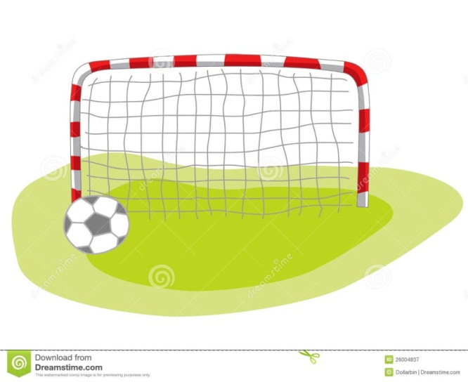

Image result for x

Line you have to shoot from

Starting point for either Boys or Girls

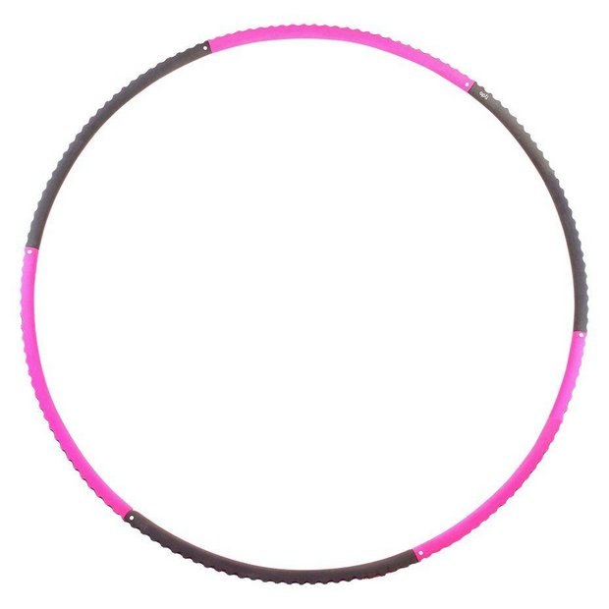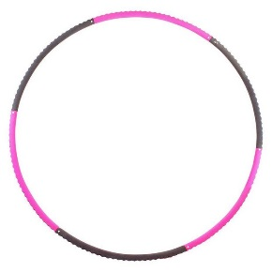 **Target Station**

1

5

2

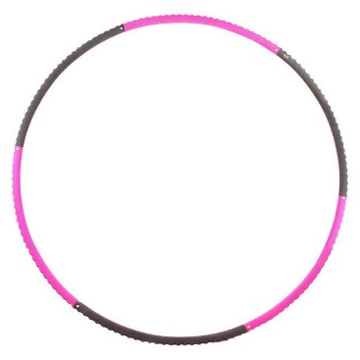

**Our event**

* Our event is focusing on target therefore the aim is to throw three bean bags into the following targets, hula hoops.
* The children will stand behind the line (one at a time) and throw the bean bags at the hoop.
* To get the point, the bean bag must land and stay inside the hoop.
* The points vary due to the closeness of the hoop e.g the closest hoop is worth 1 point whereas the hoop furthest away is worth 5. You could throw all three bean bags in the closest hoop.
* Each person gets one go to throw three bean bags. All of the points will be added up for each team e.g all the points for the girls will be totalled and added to the boys score. The aim is to get as many points as you can.

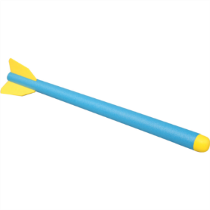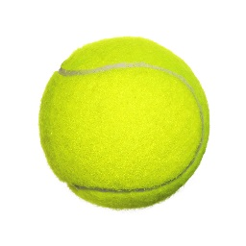

**Distance Throwing**

Introduction to our event

Our throwing event includes teams each throwing a tennis ball as far as they can and also a foam javelin. It will be split into boys and girls but the scores will be added up as a school for our event. The most important aspect to our event will be teamwork and supporting each other.

How it will work

Both genders will be lined up behind the starting line and will be numbered 1 to 5 (number 1 going first). Number 1 will throw the tennis ball as far they can and wherever it bounces will be where number 2 begins their throw (with the same ball) and so on, until you reach number 5. When number 5 throws, wherever the ball bounces is where a cone will be placed to mark the distance for both the boys team and girls team for each school.

**1**

**5**

**4**

**3**

**2**

Scoring

Once every single school has thrown and we have the cones placed on the field where each gender from each school has thrown, then we will order them from 1st place to nth place. Wherever that gender from that school has placed will determine how many points they gain. For example-1st would get 9 points, 2nd would get 8 points and so on. Then the boys and girls points will be added to reach a total for the school, for our event.

Skills you will need for our event

* Teamwork
* To be able to throw a ball and javelin a long distance

**Jumping Station**

1. The boys and the girls from the same school will line up side by side**, on a count of three, us sport leaders will blow the whistle.**
2. **One person from each line will run forward jumping over the 3 hurdles with two feet.**
3. **Once they have gone over the hurdles, they will reach the speed bounce. 10 speed bounces each. Sports leaders will be checking.**
4. **After that, they will reach the ladder which they will need to put one foot in each ladder.**
5. As they reach the end they need to sprint back to the rest of their team, high five the next person and sit down at the back of the line.
6. As soon as everyone in the line has been and SAT DOWN, we will stop the stopwatch and record the time.
7. Boys and girls times will be added together.

GIRLS LINE

**SAME ON OTHER**

**SIDE FOR BOYS LINE**

**Speed Relay**

How to play:

* You have two separate teams of 5 boys and 5 girls, within your school. Both teams line up next to their designated hoop behind the line.
* The aim is to sprint out to retrieve an object and then return to tag the next team member.
* The children have a choice to either go further away from the line to collect items and put them in their hoop or closer to the line.
* The further away the item, the more the points they receive.
* Once the whistle has been blown both boys and girls start. After 3 minutes, the whistle will be blown again to signal the children to stop. Any items collected after the whistle will not be counted.
* Children may only collect ONE item at a time.
* All points will be added together to make a final school total.

Scoring:

The closest items collect the least amounts of points.

Tennis balls: 1 point (quantity: 5 )

Yellow squish ball: 2 points (quantity: 4)

Cone: 3 points (quantity: 3)

Pink big squish ball: 4 points (quantity: 2 )

Yellow small shape ball: 5 points (quantity: 2)

Orange bell-ball: 10 points (quantity: 1)

Diagram:

BOYS XXXXX GIRLS XXXXX

**Obstacle Course**

1. Ball



The obstacle course will be set up in 2 lanes it will be a relay. 1 girl’s lane and 1 boy’s lane. It will be timed and the quickest time will get the most points.

1. It starts with a ball that you have to pass round your body 5 times.
2. Then place the beanbag on your head and walk across the line.
3. Next you jump over the 2 mini hurdles.
4. After that you run/step across the feet.
5. The place the hula-hoop over your head and down your body.
6. Then using both feet do 2 footed jumps across the 3 spots.
7. Then run/step across the feet again.
8. Next pick up the ball, throw the ball to one of the sports leaders and then catch it back. Then place it back on the floor.

Lastly run back to the start and tag the next team mate and sit down.

The race will finish when all team mates have completed the course and sat down.

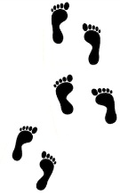

2. Bean Bag walk along line

3. Hurdles

4. Foot Prints

6. Spots

5. Hula hoop

7. Foot Prints

8. Throw and catch ball

